 | DOKUZ EYLUL UNIVERSITY  ENGINEERING FACULTY  DEPARTMENT OF COMPUTER ENGINEERING | 

CME1214 LOGIC DESIGN
PRELIMINARY REPORT

LAB 1
Boolean Algebra

by
Mesut Selim Serbes
2017510100

Lecturers
Instructor Dr. Özlem Öztürk
Res.Asst. Dr. Feriştah Dalkılıç
Res.Asst. Özlem Yerlikaya
Res.Asst. Gökmen Katipoğlu

IZMIR
12.03.2019

      - EXPLANATION
I implemented De Morgan theorem for 1.Experiment in the homework.I used three not gate and a nand gate for 2.Experiment.
      - TRUTH TABLE
1.Experiment
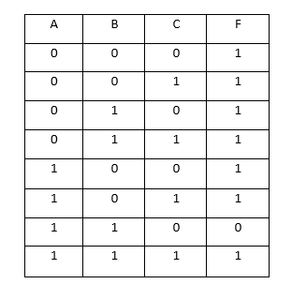
      - LOGIC DIAGRAM
1.Experiment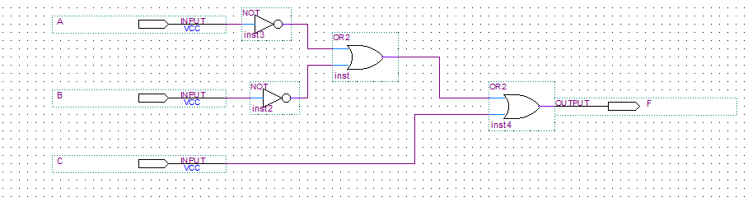

2.Experiment
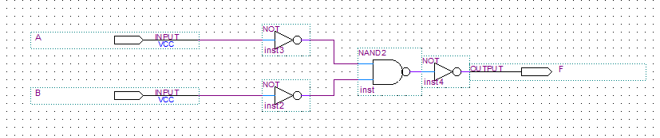
      - WAVEFORMS
1.Experiment
Functional Waveform
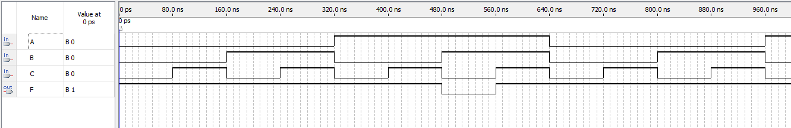
Timing Waveform
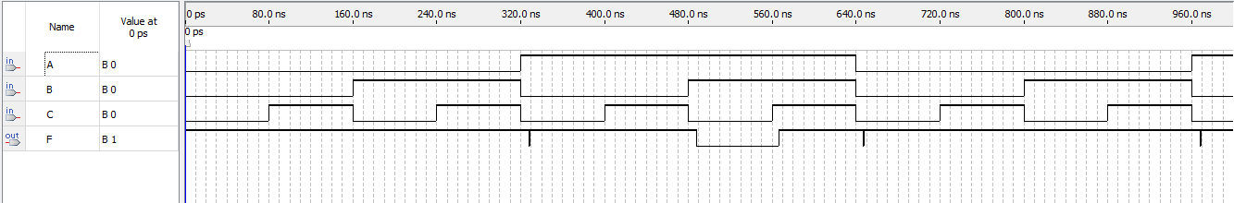
2.Experiment
Functional Waveform
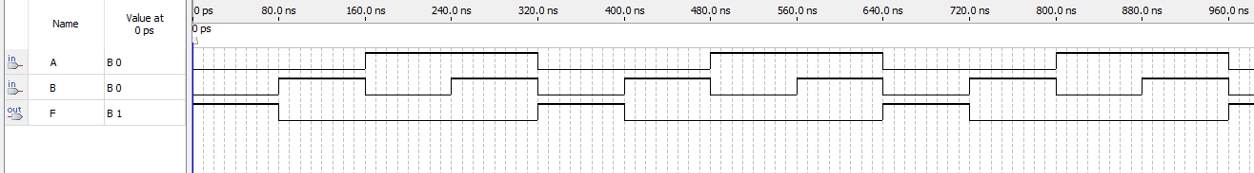
Timing Waveform
